***Project Report***

***On***

***CHATBOT***

***Submitted in the partial fulfillment of the requirements for***

***the award of Degree of B.Tech***

***By***

***ARYAN KUMAR RANA(2100680130019)***

***AKSHAT KUMAR KAKRAN(2100680130010)***

***JATIN KUMAR(2100680130026)***

***Under the Supervision of:-***

***Mr. Rakesh Sambyal***

***(Assistant Professor)***



***(Department of Information & Technology)***

***MEERUT INSTITUTE OF ENGINEERING AND***

***TECHNOLOGY, MEERUT – (250005)***



***Dr. A.P.J. Abdul Kalam Technical University, U.P., Lucknow***

***[2023-2024]***

**DECLARATION**

We hereby declare that this submission is my own work and that, to the best of my knowledge and belief, it contains no material previously published or written by another person nor material which to a substantial extent has been accepted for the award of any other degree or diploma of the university or other institute of higher learning, except where due acknowledgment has been made in the text.

**Signature**:

**Name**: ARYAN KUMAR RANA(2100680130019)

AKSHAT KUMAR KAKRAN(2100680130010)

JATIN KUMAR(2100680130026)

**Date**:

**CERTIFICATE**

This is to certify that Project Report entitled – **CHATBOT WEBSITE** which is submitted by **ARYAN KUMAR RANA(2100680130019), AKSHAT KUMAR KAKRAN(2100680130010) and JATIN KUMAR(2100680130026),** in partial fulfillment of the requirement for the award of degree B. Tech. in Department of Information Technology of Dr. A.P.J. Abdul Kalam Technical University, U.P., Lucknow, is a record of the candidate own work carried out by him/her under my/our supervision. The matter embodied in this Project report is original and has not been submitted for the award of any other degree.

**Date**: **Supervisor**

**ACKNOWLEDGEMENT**

It gives us a great sense of pleasure to present the report of the B.Tech. project undertaken during B.Tech. Second Year. We owe special debt of gratitude to our guide **Ms. Preksha Pratap(Assistant Professor)** Department of Information Technology. Meerut Institute of Engineering and Technology, Meerut for his constant support and guidance throughout the course of our work. His sincerity, thoroughness and perseverance have been a constant source of inspiration for us. It is only his cognizant efforts that our endeavors have seen light of the day.

We also do not like to miss the opportunity to acknowledge the contribution of all faculty members of the department for their kind assistance and cooperation during the development of our project. Last but not the least, we acknowledge our friends for their contribution in the completion of the project.

**Signature:**

**Name: ARYAN KUMAR RANA(2100680130019)**

**AKSHAT KUMAR KAKRAN (2100680130010)**

**JATIN KUMAR(2100680130026)**

**Date:**

**TABLE OF CONTENT**

|  |  |  |
| --- | --- | --- |
| **S.No.** | **Description** | **Page No.** |
| **1** | **Declaration** | **2** |
| **2** | **Certificate** | **3** |
| **3** | **Acknowledgement** | **4** |

|  |  |  |
| --- | --- | --- |
| **Chapter No.** | **Description** | **Page No.** |
| **Chapter 1** | **Introduction** | **6** |
| **Chapter 2** | **System Design**  **(Flowchart/constructional**  **Details of individual components)** | **7-8** |
| **Chapter 3** | **Output Screens** | **09-12** |
| **Appendices** | **Implementation of code** | **13-21** |
| **References** |  | **22** |

**CHAPTER 1**

**INTRODUCTION**

Nowadays, different virtual assistants guide us on websites of banks, financial institutions, hotels, museums, universities, etc. We rely on them not only to get a job done or to find a place on Google Map, but also for searching new pieces of information on the web or for acquiring new knowledge and skills in a particular area.

This is especially true for younger generations and economically active people, who are used to computer or phone assistants, like Cortana, Alexa, Siri, etc. for their everyday work and life. All these pose new challenges in front of adult educators, teachers, tutors and training professionals,

who should adapt to this new learning reality. They need to continuously develop their competences

and to incorporate innovative educational practices and tools for creating unique tailor-made learning and for meeting the raised expectations of today’s learners. In 1966, an MIT professor named Joseph Weizenbaum created the first chatbot. He cast it in the role of a psychotherapist. A user would type a message on an electric typewriter connected to a mainframe. After a moment, the “psychotherapist” would reply.

**SCOPE**

**1. Customer Support:** Chatbots are frequently used in customer service to provide assistance and answer commonly asked questions.

**2. Automation:** They are designed to automate tasks and processes that would otherwise require human intervention.

**3. Information Retrieval:** They can search databases, provide real-time updates, and deliver relevant information based on user queries.

**4. Entertainment:** These chatbots may offer games, quizzes, or virtual companionship.

**5. Data Collection and Analysis**

**SOFTWARE DEVLOPMENT METHODOLGY**

* The present Methodology provides an entry-level knowledge about the chatbot technologies and how they could be used in adult education, with a focus on online and blended learning environments. This way, we want to equip educators and training professionals with general theoretical knowledge about the specifics of applying such digital tools in the educational process and how to incorporate them into classrooms.
* The Methodology consists of three parts. The first one is dedicated to the basic terms and definitions, purposes and fields of use of chatbot technologies. The second part is focused on chatbot-based learning and how to incorporate chatbot technologies into the educational process and for self-learning. The last part includes links to additional resources and references on the topic.
* Although some authors distinguish ‘chatbots’ and ‘bots’, as the first ones are based on text-message interaction with users, while latter might include voice or even video-based communication and inclusion of artificial intelligence, for the purposes of the present Methodology, we will use these two terms as interchangeable.

**CHAPTER 2**

**SYSTEM DESIGN**

1. **Support and customer service**

One of the main reasons for why use chatbots in general is because many support questions can be easily answered with a chatbot. Chatbots allow live support people to handle difficult questions that require a human touch. More importantly, the user is immediately satisfied by getting an answer to their question 24X7.  If a question is too difficult for the chatbot to answer, the bot can switch the user to a live chat with a human or transfer the user to a live phone call. A virtual assistant chatbot answers these questions in a conversational way, and the user’s questions are collected and evaluated to improve your customer support department.

The sales process for any product or service can be, in fact is, complex. From the prospect’s view, they want to know if the product or service will match their use case and price. From the company’s viewpoint, the sales person wants to qualify the prospect to understand if the prospect’s use case and budget are a good match for their product or service. Good lead generation support ask questions to fill out a traditional form in a conversational way then send the lead to the companies CRM.

‍

1. **Surveys**

To know what your customers are thinking, you must ask them questions. A survey is a useful tool for this type of data collection. You can use it inside a chatbot to engage users by asking questions in a conversational way such that the user does not know they are part of a survey. The user responds to the questions and the response is collected and stored to reveal new information about user preferences and behaviour. The data collected from a survey chatbot is useful for future marketing and sales campaigns.

Please note. This process is not to deceive the customer but to collect information that they readily want to provide. Businesses can use this customer information to improve the customer experience.

‍

1. **eCommerce sales**

There are two conversion funnels on an e-commerce site. They are:

* Home page, category page, product page and cart
* Cart, checkout, order completed

Both of these conversion funnels have areas with high drop rates where users leave the site. In the first funnel, the user may have questions about the product. This process is solved with e-commerce support directing the user to a product quickly, as well as up-selling other products that go along with it. Over time, the bot can track what was purchased in the past and provide suggestions that coincide with the user’s likes and desires.  In the second funnel, the user may have questions about taxes, shipping, coupons, return policy, etc.

eCommerce sites have higher conversion rate when chatbots are answering questions and overcoming obstacles.

Overall website conversion rate is improved because the user experience is more engaging and helpful than a list of pages on a website. A chatbot works like a store employee who comes up to you at the store and offers assistance.

As more and more websites start using chatbots, your customers and prospects will expect a certain level of service from a site and chatbot. This is especially true because the number of mobile users is still increasing and viewing large sites on a phone is difficult. The concept of clicking multiple pages on a site to find information compared to asking a question and immediately getting an answer will soon be outdated.

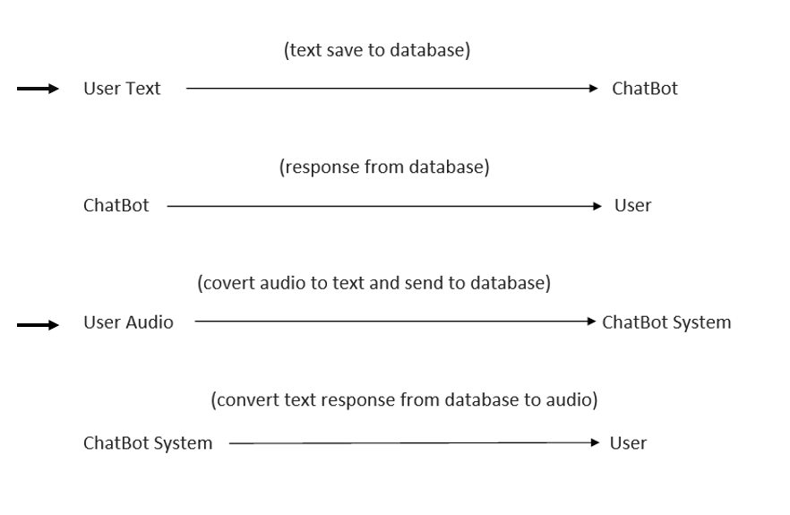

**CHAPTER 3**

**OUTPUT SCREENS**

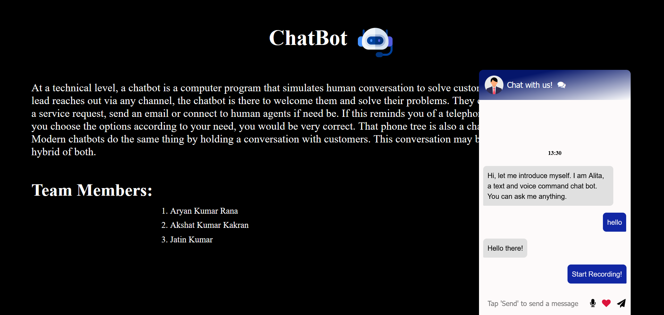

**CHAPTER 4**

**TECHNOLOGY USED**

1. **HTML**
2. **CSS**
3. **JAVASCRIPT**
4. **PHP**
5. **MYSQL**

**APPENDICES**

***IMPLEMENTATION CODE***

**INDEX PAGE:**

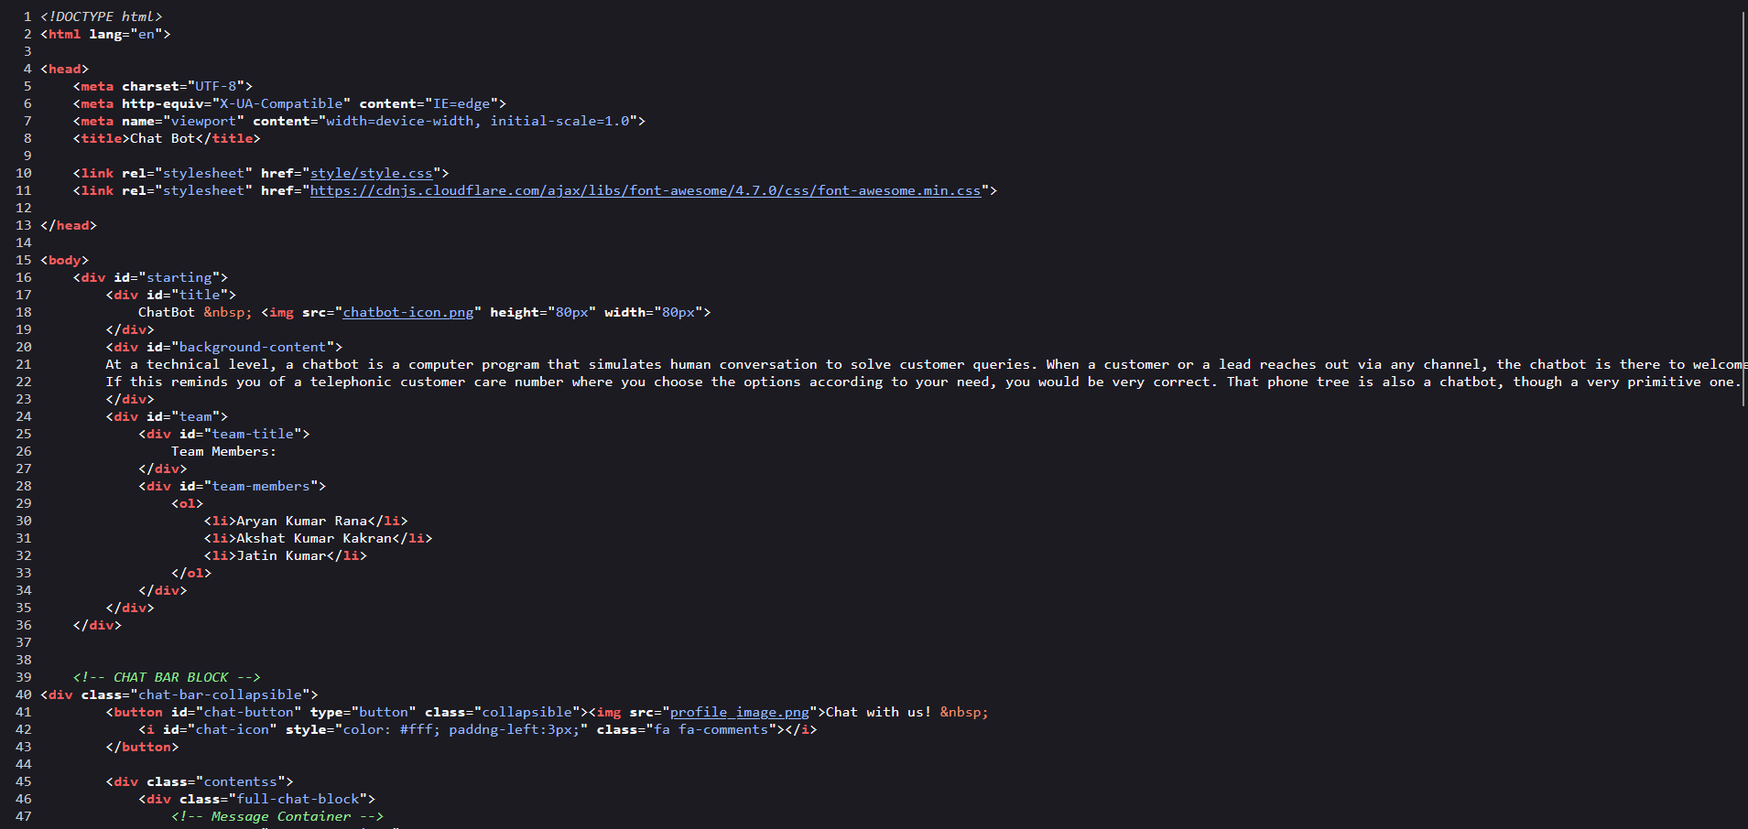

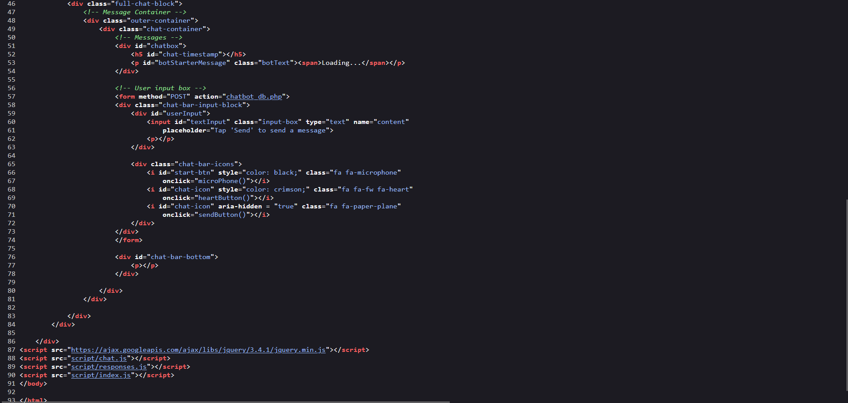

**VOICE RECOGNITION JS CODE:**

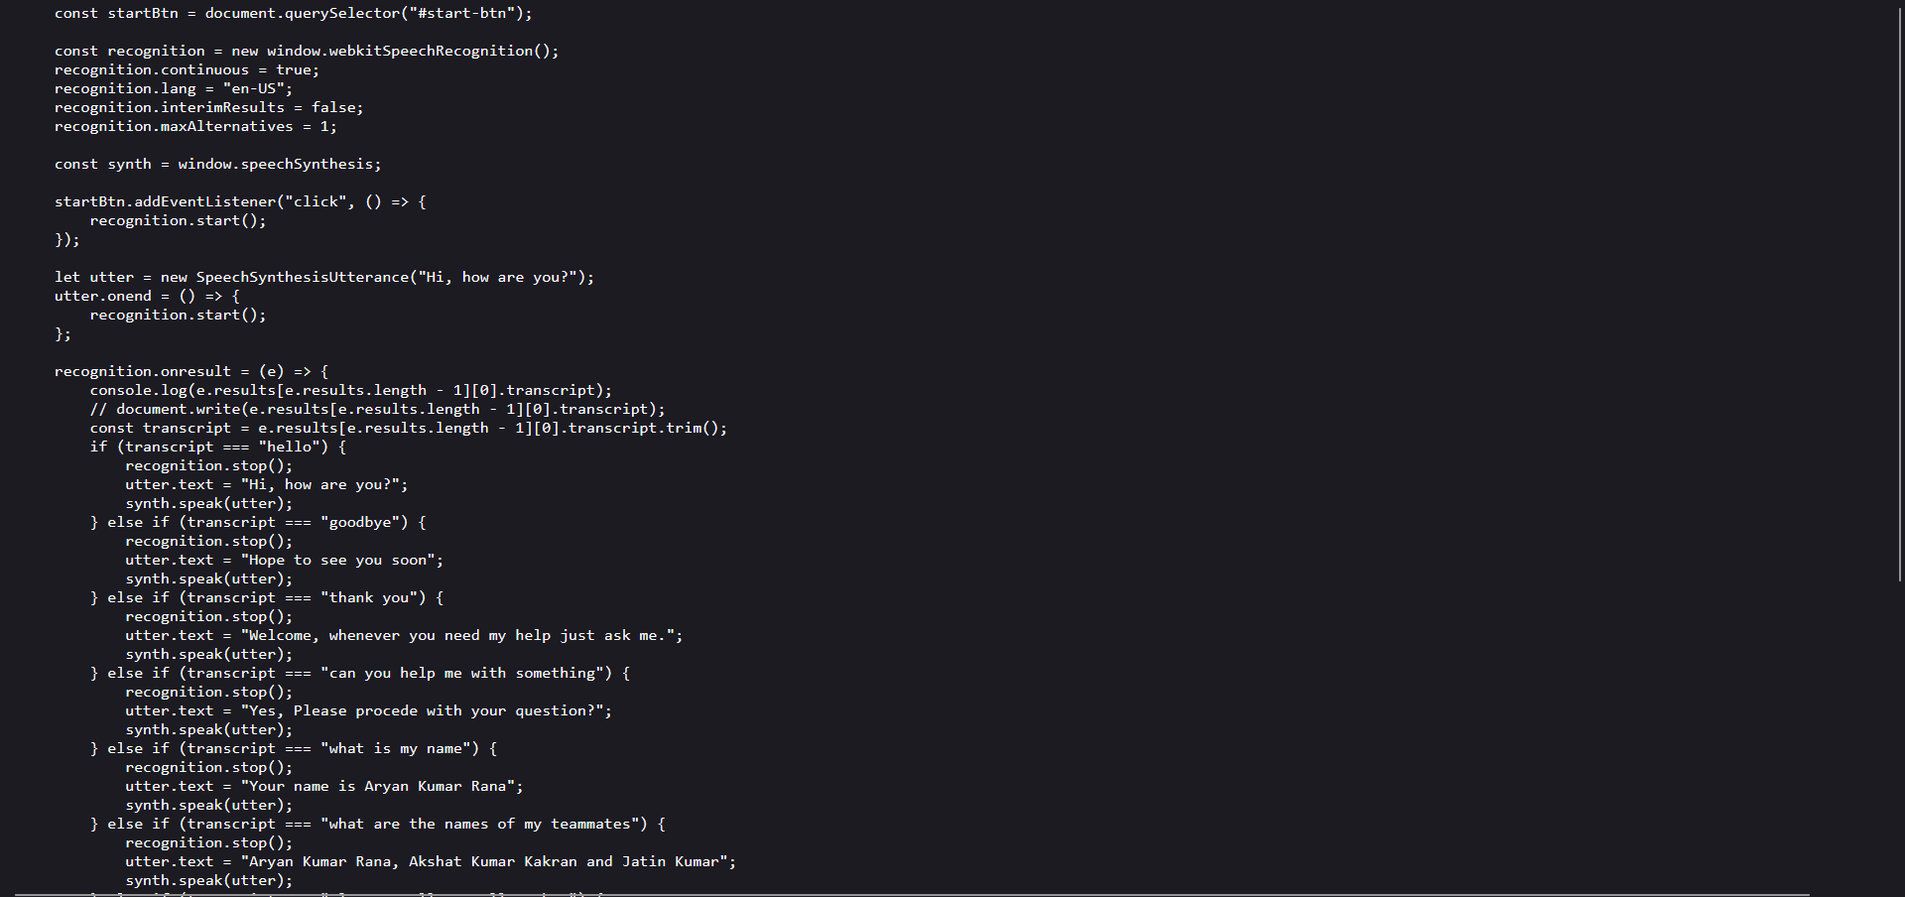

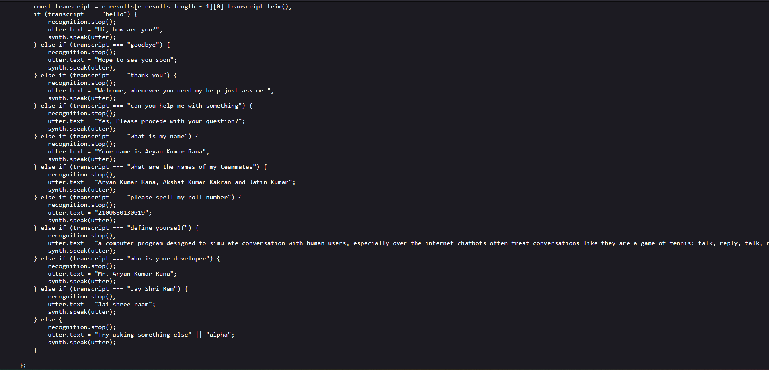

**CHATBOT JS CODE:**

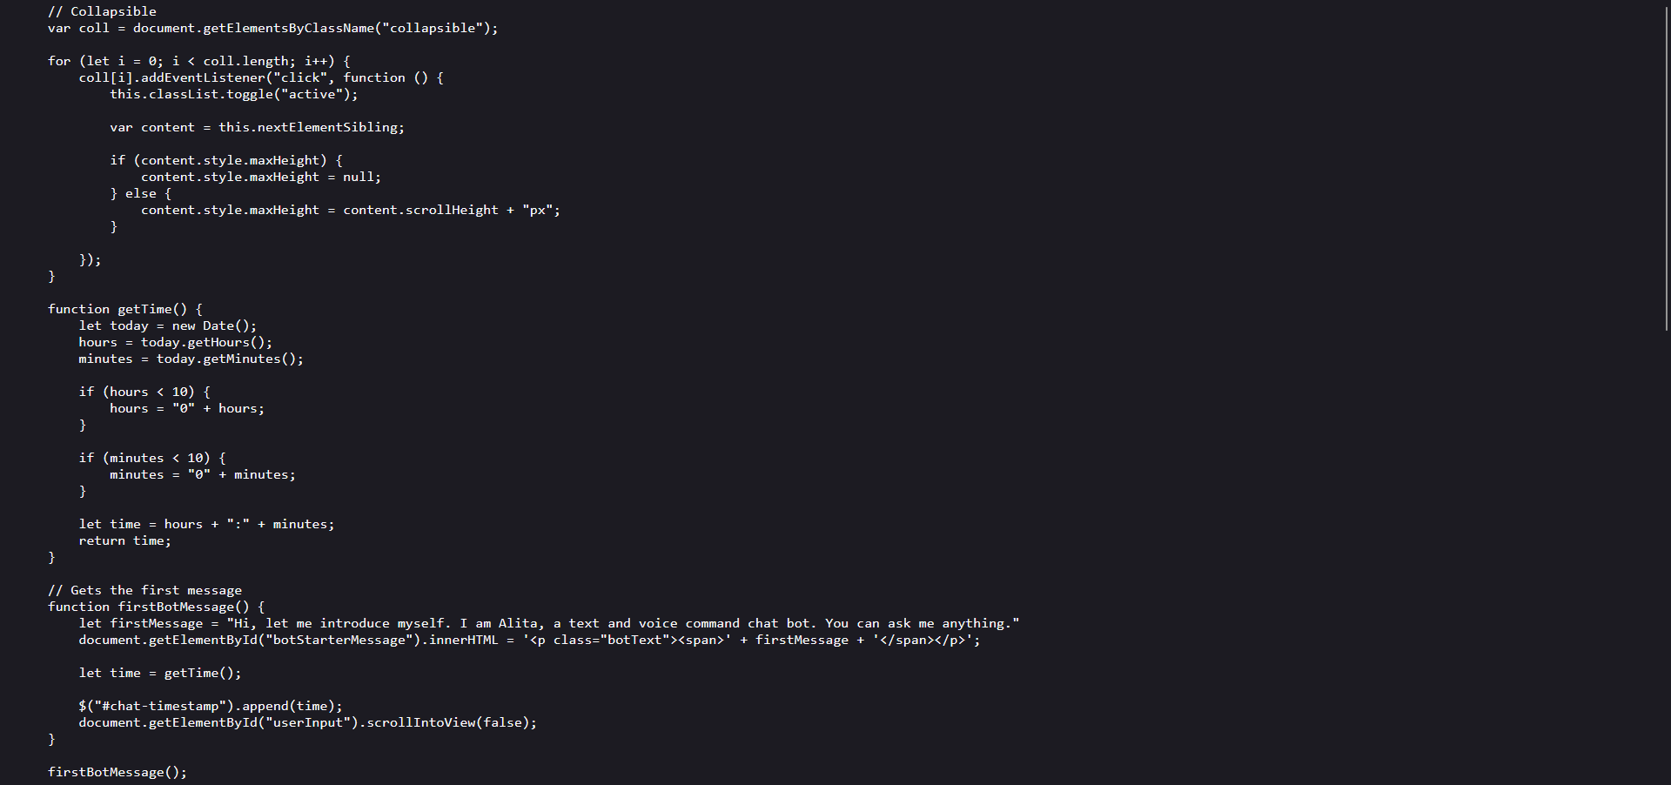

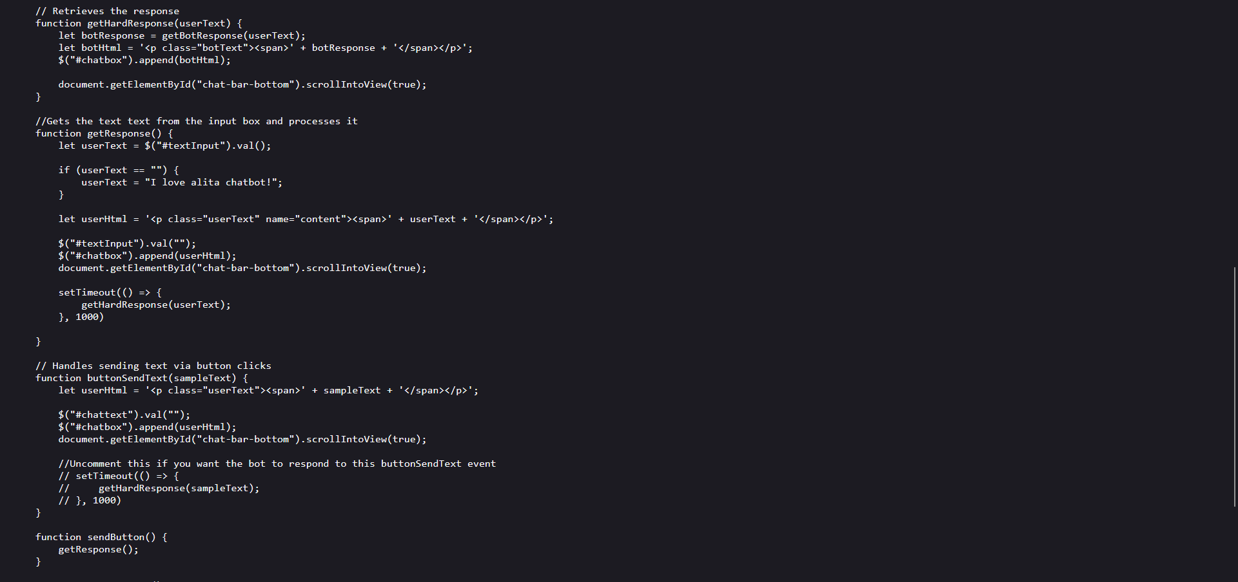

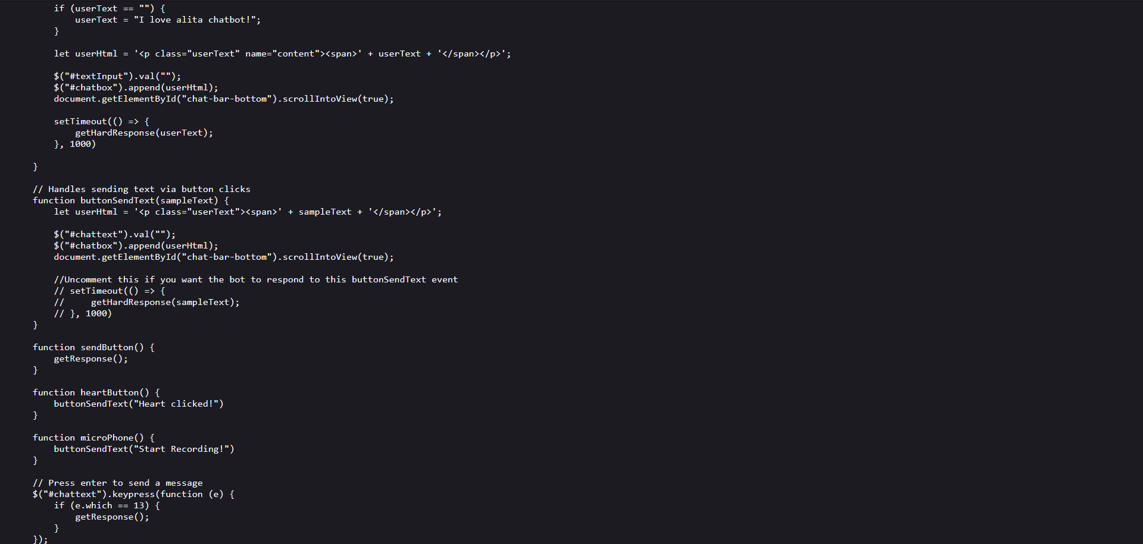

**REFERENCES**

1. w3schools.com
2. google.com
3. youtube.com
4. wikipedia.com